**Mathematics Methods Unit 4**

**Investigation 2: DRV Validation**

Name: ____________________

Time allowed: 35 minutes Calculator Assumed Marks: /31

Prolonged exposure to loud music can result in hearing loss. The two major characteristics of sound are intensity and frequency (pitch). We are only considering intensity of sound, *I*, which is measured inwatts/m 2.

The sound intensity level, *L,*  is a logarithmic measure given as

*L* = 10 log $\left( \frac{I}{I_{0}}\right)$ and measured in decibels (dB)

*I* = 10 -12 watts/m 2.

The reference intensity of sound, *I*, that all other intensities are compared to is

10-12 watts/m2 because this is the weakest intensity of sound that can be detected by the human ear.

**Question 1 [2 marks]**

Determine the sound intensity level of normal piano practice when the intensity of the sound of the music is 10- 5 watts/m 2.

**Question 2 [4, 3 = 7 marks]**

The maximum sound intensity level of an orchestra playing is 110 dB.

1. The sound intensity level of a live performance of a rock band can reach 135 dB**.** Howmany times more intense is the sound of the music of a live rock band than the music of an orchestra? (4 marks)
2. The sound intensity level of chamber music in a small auditorium is around 90 dB. How many times less intense is the sound of the chamber music than the music of an orchestra? (3 marks)

**Question 3 [1, 1 = 2 marks]**

1. Given the range of the sound intensity levels, *L*, of the following musical instruments, which two instruments have the potential to do the most damage to the human ear?

(1 mark)

|  |  |
| --- | --- |
|  | *L* (dB) |
| Violin | 84-102 |
| Cello | 82-93 |
| Oboe | 90-94 |
| Flute | 85-110 |
| Piccolo | 95-112 |
| Clarinet | 92-102 |
| French horn | 90-105 |
| Trombone | 85-114 |
| Timpani and bass drum rolls | 107 |

(b) What other factors need to be considered? (1 mark)

**Question 4 (2, 3, 1, 1, 1, 2, 2 = 12 marks)**

The table below shows the average sound intensity levels (*L*) and the intensity of the sound (*I*) of some instruments of a symphony orchestra. The ratios $\left( \frac{I}{I_{0}}\right)$ are also given for each instrument.

(a) Determine the missing values (i) – (iv) (2 marks)

|  |  |  |  |
| --- | --- | --- | --- |
| musical instrument | average sound intensity level, *L*  *(* dB *)* | $\left( \frac{I}{I_{0}}\right)$ | intensity of sound, *I*  *(* watts/m 2 ) |
| Violin | 93 | 1 995 262 315 | 0.0019953 |
| Cello | 87.5 | (i) | (iii) |
| Oboe | 92 | 1 584 893 192 | 0.0015849 |
| Flute | 97.5 | 5 623 413 252 | 0.0056234 |
| Piccolo | 103.5 | (ii) | (iv) |
| Trombone | 99.5 | 8 912 509 301 | 0.0089125 |
| Timpani and  bass drum rolls | 107 | 50 118 723 360 | 0.0501187 |

(b) Plot the intensity of sound (*I* watts/m 2 )against the average sound intensity level

(*L* dB) for any four of the musical instruments listed in the table above. (3 marks)

0.1000

Intensity

of sound,

*I*

0.0100

0.0010

0.0001

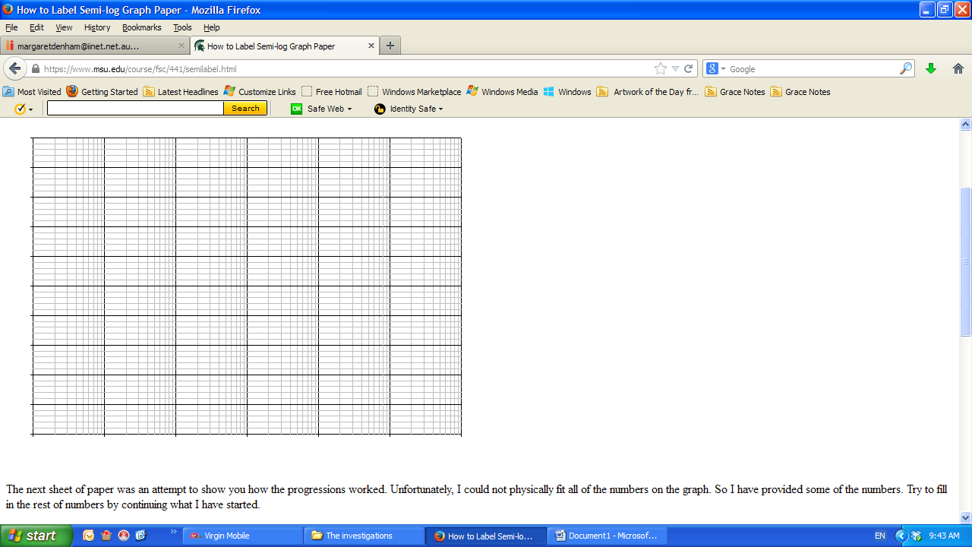

85 90 95 100 105 110

Average sound intensity level, *L*

**Question 4 (continued**

(c) Identify the relationship between the points you have plotted. (1 mark)

(d) Using the graph or otherwise, determine the average sound intensity level of the sound from a musical instrument that has an intensity of sound of 0.1 watts/m 2. (1 mark)

(e) Explain why a semi – logarithm grid was useful for the data graphed. (1 mark)

(f) (i) What shape would the *L* – *I* graph take? Explain your decision. (2 marks)

(ii) Using your calculator or any other method, determine the equation that best fits the *L* – *I* data. (2 marks)

**Noise exposure**

It is said that an increase of 3 decibels in sound intensity level will double the intensity of the sound.

**Question 5 [4, 4 = 8 marks]**

(a) By finding an expression for *I* at a sound intensity level of 80 dB and *I* at a sound intensity level of 83 dB, show why increasing the sound intensity level by 3 dBdoubles the value of *I.* (4 marks)

(b) Show how this is the case at any sound intensity level. (4 marks)